DEFENCE FORCES MEDICAL INSURANCE SCHEME REGISTERED TRUSTEES

Defence Forces Medical Insurance
Scheme
Nyayo House
P.O. Box 21710 - 00100
NAIROBI, KENYA

MAY 2026

Telegrams: “DEFMIS”, Nairobi Telephone: 020-2340489/
020-2721100 Ext: 5626
Email: info@defmis.org
When replying please quote
Ref: DEFMIS/A/6

DEFMIS MEDICAL BILLS Q1 2026 REVIEW
1. This report analyses the Defence Forces Medical Insurance Scheme (DEFMIS) for the first quarter of FY 2026 (January–March 2026), as directed by the Inter Office Memo dated May 14, 2025 (ref: DEFMIS/A/6) from SOI Pers & Admin. The purpose of the report is to audit the first quarter of FY 2026 medical expenses.
COMMITTEE MEMBERS
2. The following members were selected to oversee the review of refunds and card issuances Q1 2026.
- Lt Col S K Kavusyu - Chairman
- Maj R J Ntoruru - Deputy Chairman
- Capt. N Mohamed - Claims
- Capt K O Nyagol - Med Rep
- 106477 WOI Rop - Med Rep
- 71470 WOII Ngari - Reg II
- 109046 SSgt Wafula - ICT
- Capt. D M Ahmed - Secretary

3. The committee was tasked with a comprehensive evaluation of factors contributing to the increase in medical bills and providing recommendations.

TRUST DEEDS MENTIONS
- The DEFSI NO. 1 OF 2017 guidelines provide the following relevant provisions:
Rule 5.28: "The Board of Trustees, Board of Management and Managing Director may at any time order a Suprise inspection, check of any account or records of the trust if they deem necessary “.

QUARTER 1 2025 AND Q1 2026 COMPARISON
- DEFMIS recorded incurred claims amounting to Ksh 248.69 million in Q1 2026, compared to Ksh 209.18 million in Q1 2025, representing an increase of approximately 18.9%. The growth in expenditure was largely driven by increased utilization of healthcare services, particularly outpatient services following the removal of co-payment requirements at UHSF and faith-based facilities, as well as the implementation of the pharmacy-first approach. While this led to higher short-term costs, it presents several advantages, including improved access to healthcare services for members, earlier treatment of conditions before complications arises, reduced barriers to seeking care, and enhanced overall health-seeking behavior. The breakdown is as shown below;
- January accounted for Ksh 74.4 million.
- February accounted for Ksh 87.51million.
- March accounted for Ksh 86.77million.
- The increase in expenditure was largely driven by Inpatient Hospitalization and Outpatient Overall services, which jointly accounted for the majority of total claims costs.

Distribution of Claims by Visit Type – Q1 2026
Visit Type | Jan (Ksh) | Feb (Ksh) | Mar (Ksh) | Grand Total (Ksh)
In Patient Overall | 37,224,256.36 | 54,310,762.71 | 51,813,020.26 | 143,348,039.33
Out Patient Dental | 846,007.01 | 775,734.86 | 743,565.84 | 2,365,307.71
Out Patient Optical | 1,785,748.59 | 1,750,569.41 | 1,590,303.93 | 5,126,621.93
Out Patient Overall | 34,546,439.86 | 30,676,619.24 | 32,628,808.54 | 97,851,867.65
Grand Total | 74,402,451.82 | 87,513,686.22 | 86,775,698.57 | 248,691,836.62

- Inpatient services accounted for the largest share of healthcare expenditure during Q1 2026 at 57.64% of total costs, compared to 70% in the previous years, indicating a relative decline in inpatient cost burden. Conversely, outpatient expenditure increased to 39.35% from 30% past financial years, mainly attributable to the removal of co-payment requirements at UHSF and faith-based facilities, as well as the implementation of the pharmacy-first approach, which encouraged greater utilization of outpatient and pharmaceutical services. Optical and dental services accounted for a combined 3.01% of the total expenditure.
- An analysis of the age-based expenditure for Q1 2026 reveals that members aged 50 to 79 years account for the overwhelming majority of medical costs, with a total incurred amount of Ksh 207.57 million, representing approximately 83.47% of the total Q1 2026 expenditure of Ksh 248.69 million. This highlights a significant financial burden driven by older beneficiaries, likely due to increased prevalence of chronic illnesses and higher healthcare utilization within this age group. The 20–49 years age group recorded the second-highest expenditure at Ksh 19.52 million (7.8%), followed closely by the 0–19 years age group at Ksh 16.84 million (6.8%). Members aged 80 years and above accounted for the lowest expenditure, totaling Ksh 4.76 million (1.9%). Overall, the findings indicate that healthcare costs are heavily concentrated among members aged 50 years and above, emphasizing the need for targeted cost management and preventive healthcare interventions for aging beneficiaries as shown in the table below.
Age Bracket | Amount | No of Members | % of Total Cost
0-19 | 16,838,536.00 | 887 | 6.77%
20-49 | 19,515,460.45 | 723 | 7.85%
50-79 | 207,573,734.75 | 4,350 | 83.47%
80+ | 4,764,105.42 | 29 | 1.92%
Grand Total | 248,691,836.62 | 5,989 | 100%

- This trend highlights the increasing healthcare needs and associated costs among older members, especially those managing chronic or degenerative conditions, reinforcing the importance of targeted chronic disease management strategies for cost control.
- Out of the total Ksh 248,691,836.62 incurred in Q1 2026, approximately Ksh 141,896,869.06, representing about 57.1%, was processed through Letters of Undertaking (LOUs). The availability of detailed LOU reports within our records significantly enhanced the accuracy of the analysis, allowing for a clearer understanding of disease burden and major cost drivers, as these reports include specific diagnoses and treatment details.
- The infographic below presents the distribution of healthcare expenditures by condition group, highlighting the major cost drivers and their percentage contribution to the overall medical expenditure for Q1 2026.
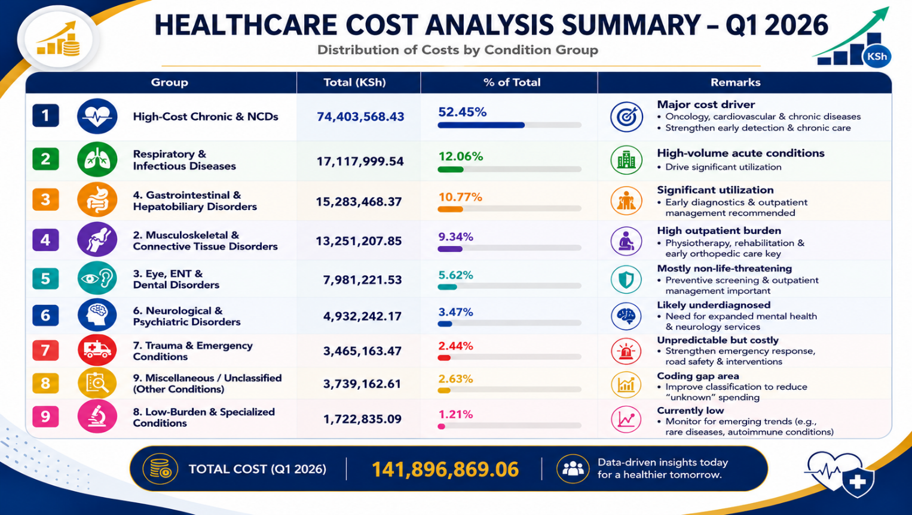
- The infographic below presents an analysis of LOU expenditures by condition group and age bracket, showing the leading cost drivers and their proportionate contribution to total healthcare expenditure during Q1 2026.
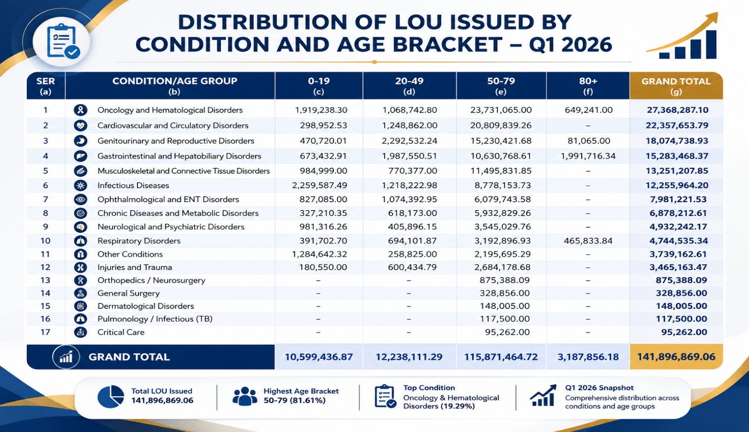
- Healthcare claims expenditure totaling Ksh 141.9 million is concentrated in a few key disease categories, with Oncology and Hematological Disorders (Ksh 27.37M) emerging as the highest cost driver this quarter, followed by Cardiovascular and Circulatory Disorders (Ksh 22.36M), Genitourinary and Reproductive Disorders (Ksh 18.07M), and Gastrointestinal and Hepatobiliary Disorders (Ksh 15.28M).
- This represents a shift in the cost burden pattern, where Oncology has overtaken Cardiovascular and Circulatory Disorders as the leading expenditure category compared to the previous years, indicating a rising financial impact of cancer-related care within the scheme.
- A strong concentration of expenditure is observed in the 50–79 age group, which accounts for Ksh 115.87M (81.6%) of total costs, making it the dominant driver of healthcare utilization. The 20–49 age group contributes Ksh 12.24M (8.6%), followed by the 0–19 age group at Ksh 10.60M (7.5%), and the 80+ age group at Ksh 3.19M (2.2%). Overall, the data shows that healthcare expenditure is heavily driven by older members, particularly those aged 50–79 years, and a small number of high-cost chronic and complex conditions. The shift in top cost driver from cardiovascular conditions in the previous year to oncology in the current year highlights an evolving disease burden profile, underscoring the need for strengthened prevention, early detection, and structured disease management strategies, particularly for high-cost chronic conditions.

OBSERVATIONS
- Analysis of Q1 2026 LOU data reveals that over 83.47% of healthcare expenditure was driven by members aged between 50 to 79 years. This trend highlights the significant impact of age-related and chronic conditions on medical costs.
- Oncology cases remained a significant cost driver during the review period, highlighting the importance of early screening and detection initiatives, including integration of cancer screening services during medical camps where feasible.
- There has been a noticeable rise in chronic diseases among members, with an increasing number of patients being newly diagnosed with long-term conditions. These factors, combined with the prolonged hospital stays for individuals battling chronic or complicated health issues, significantly drive-up costs and strain available resources.

RECOMMENDATIONS
- To address the identified issues, the committee recommends:
- Enhance Chronic Disease Management through screening, digital monitoring, and education.
- Strengthen oncology management through enhanced early screening and detection initiatives, including incorporation of cancer screening services during medical camps where feasible.
- To ensure long-term sustainability and reduce the financial burden on DEFMIS, a cost-benefit analysis should be conducted to determine whether beneficiaries with chronic diseases should be enrolled under the Social Health Authority (SHA). Implement Data Quality Improvement Initiatives, including standard diagnosis coding and LOU categorization.
- Target Elderly Members for specific wellness and preventive care programs.

CONCLUSION
EVALUATION REPORT PREPARED AND CONFIRMED BY:
Sign …………………. Date........................
S K Kavusyu
Lt Col
SO1 Per & Admin/Chairperson

Sign …………………. Date........................
D M Ahmed
Capt
Business Analyst/Secretary

